November 2022

Salish Sea Estuaries Avian Monitoring Framework
Draft summary for review

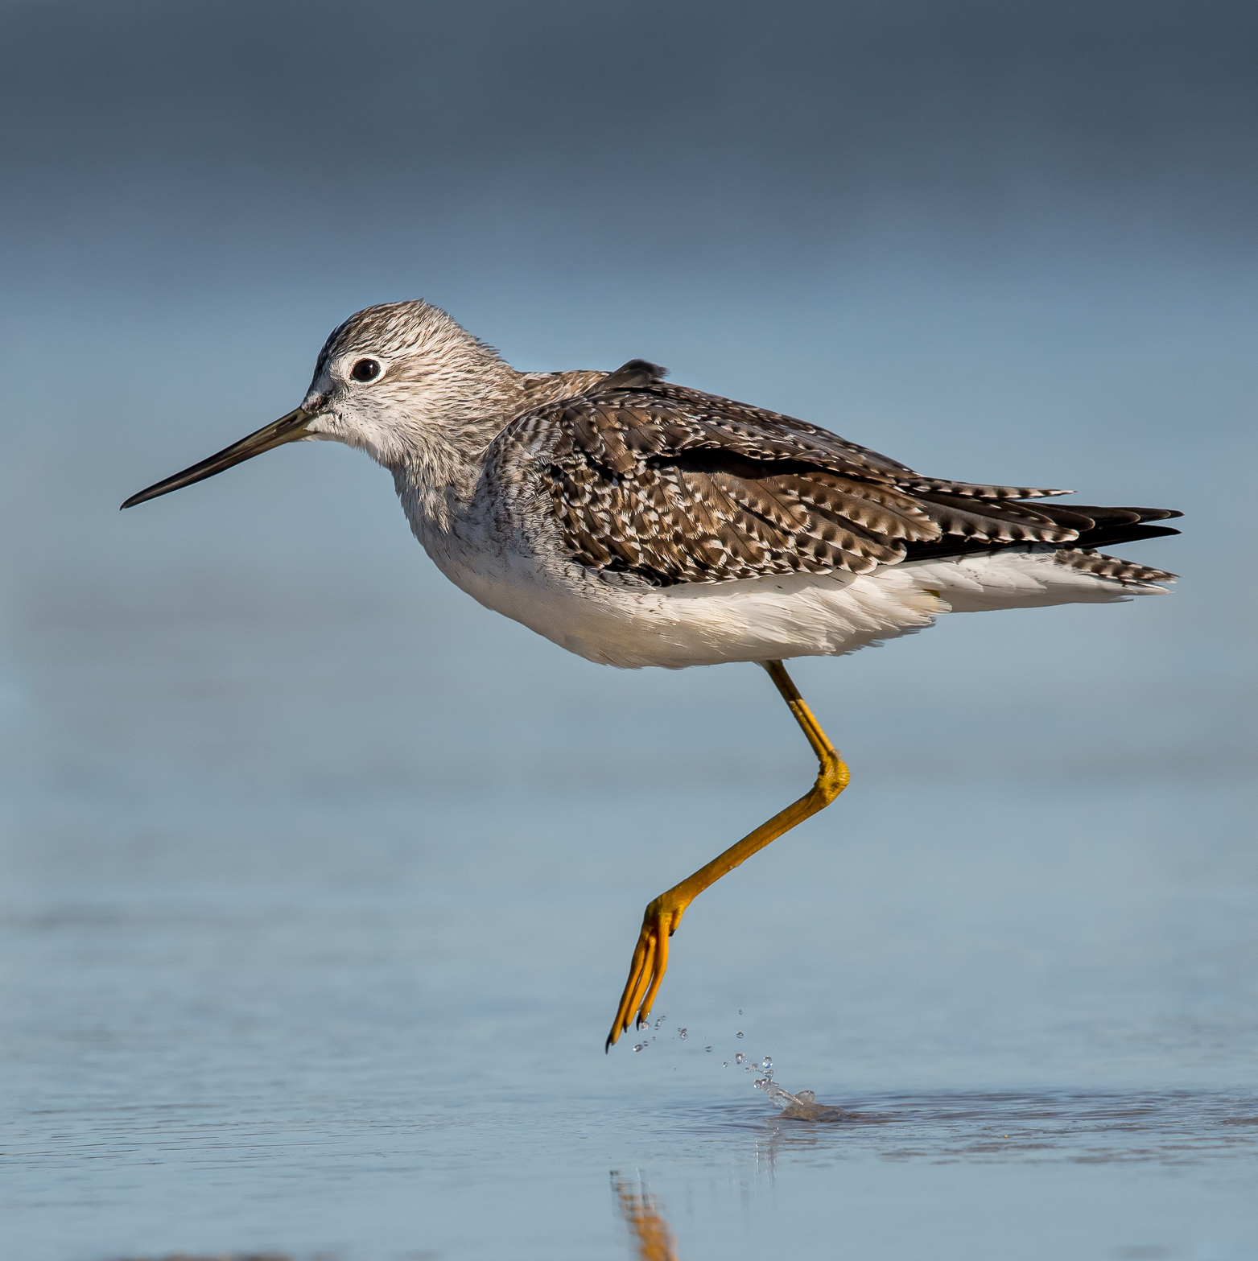

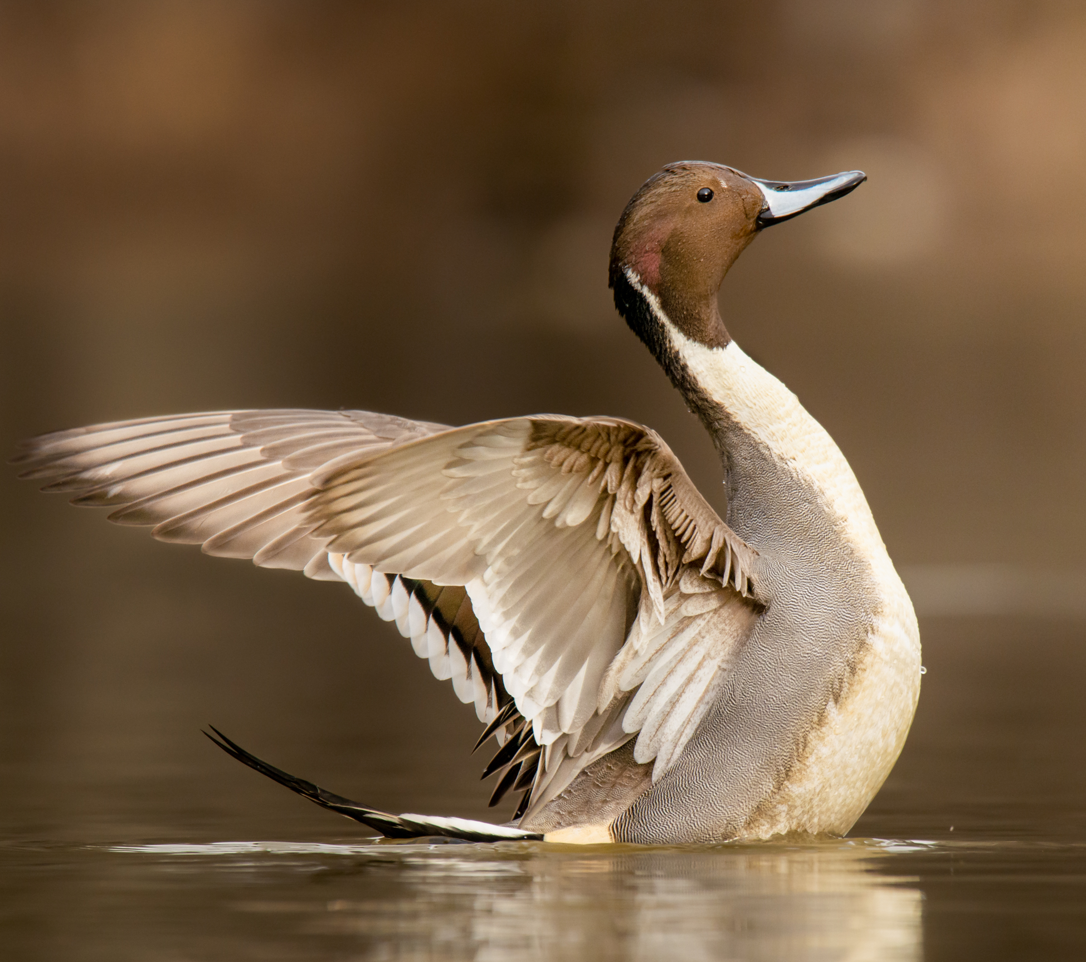

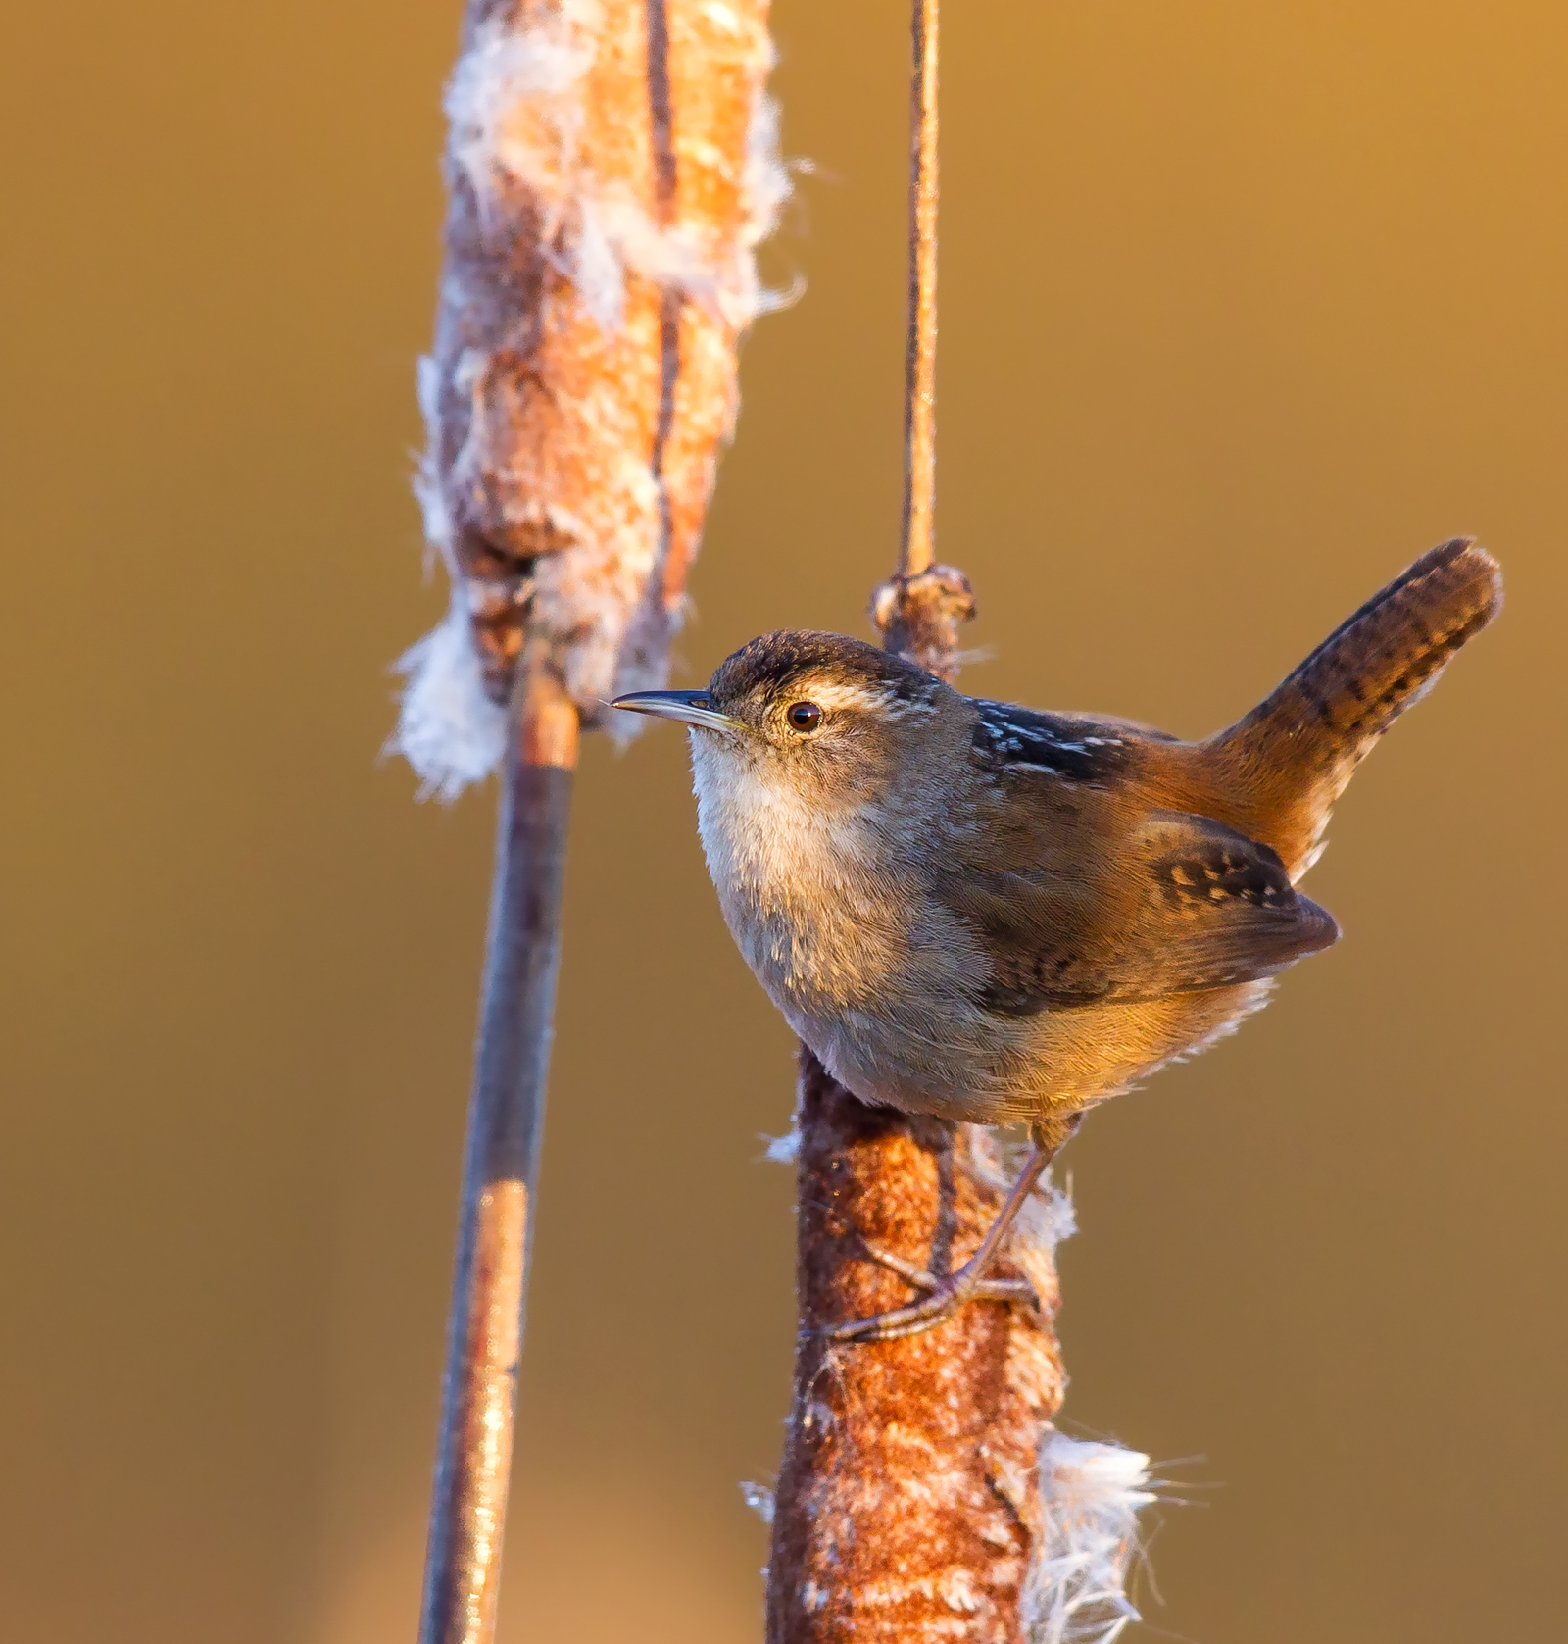

Species. Greater Yellowlegs
Photo: Melissa James

Species. Northern Pintail
Photo: Nick Vance
Marsh Wren
Photo: Boe Baty

However, inference on the mechanisms driving avian response will be constrained until we can collectively improve our understanding of fine-scale avian habitat associations.

Ecological goal
The ecological goal of this monitoring framework is to determine regionally specific avian habitat associations and patterns of estuary habitat use that informs site protection, restoration, and conservation efforts, evaluation of avian response to management, and informs modeling to predict the effects of climate change.

Implementation goal
The practical goal of this effort is to develop a regional monitoring framework for estuary birds that creates a shared set of field protocols for use throughout the Salish Sea. Together, we can generate complimentary data sets that help elucidate avian habitat associations and meet stakeholder information needs for estuary management and restoration (Bayard et al. 2019).

Geographic scope
Salish Sea estuaries

Our approach
The Salish Sea Estuaries Avian Monitoring Framework is a collaboration of the Stillaguamish Tribe, Audubon Washington, Ecostudies Institute, and Washington Department of Fish and Wildlife. The Framework is part of a multi-year effort to support avian management and conservation in the region. We have aimed to develop a monitoring framework that addresses shared information needs amongst local resource managers and provides flexibility in terms of the scope and scale of participation. Based on these criteria and end-user input, we selected fine-scale avian habitat associations within the low marsh zone as a foundational, shared goal for inquiry that we hope others will adopt.

Fine-scale habitat relationships can be used to inform restoration design and can be used to generate testable predictions about avian response to management. With this information in hand, the Salish Sea avian monitoring community will be better positioned to address long-standing questions about avian response to restoration at the site and regional scale (Koberstein et al. 2017).

Recognizing that grant obligations may drive a focus on measuring avian response to restoration, we also provide protocol modifications to tackle this question.

Target species groups  - Wintering and pre-breeding waterfowl  - Wintering and migratory shorebirds  - Breeding secretive wetland birds  - Breeding landbirds | target habitats  - Estuarine wetlands  - Adjacent levees/dikes  - Pre-restoration habitats

Target Species. The target species groups were identified based on their prevalence in the low marsh zone and their status as priority species for management interests. However, all species are recorded during field surveys so there are opportunities to obtain additional information on non-target species. We have divided the four target species groups into distinct survey modules with protocols that can be implemented on their own or in combination, depending on the interests and capacity of end-users. The modules and their associated protocols are designed to be complementary and can easily be combined.

Target Habitats. The sampling design and survey protocols are focused on avian use of low marsh habitats. Low marsh is defined as the area dominated by sedges and bulrushes, including Carex lyngbyei (Lyngby's sedge), Schoenoplectus pungens (American bulrush), and Bolboschoenus maritimus (maritime bulrush). Vegetation density in the region is variable and includes unvegetated areas where vegetation dies back to moderately dense stands of dead vegetation (approximately 25-50% vegetation cover). The transition between high and low marsh is denoted as the area where sedges and bulrushes of the low marsh transition to more dense stands (>50% vegetation cover) and vegetation communities became dominated by Schoenoplectus tabernaemontani, (soft-stem bulrush), Typha angustifolia (narrow-leaf cattail) and woody shrubs (e.g, sweetgale [Myrica gale], willow [Salix spp.]).
Secondary habitats of interest include adjacent levees and dikes, and pre-restoration habitats such as agricultural fields, muted tidal marshes, and freshwater marshes that have human-caused barriers to tidal flow.

sampling design

The sampling approach is based upon a grid design established for an area of interest (Figure 1). The sampling design and protocols for the Salish Sea Estuaries Avian Monitoring Framework were developed and tested by Ecostudies Institute, with funding from the Puget Sound Estuary and Salmon Restoration Program (ESRP) and modified for this Framework with funding from the Stillaguamish Tribe of Indians and support from Audubon Washington and Washington Department of Fish and Wildlife (WDFW). In some cases, the area of interest, or site, will be too small to achieve our ecological goal at the site scale. A major benefit of this sampling design is that data can be pooled across sites to yield generalizable results at larger scales.

The species modules and protocols presented below are focused on our primary monitoring objective: to determine fine-scale habitat associations within low marsh habitat. The differences amongst the species modules are relatively minor and relate to season of interest and tidal survey window, making implementation of multiple species modules relatively straightforward (Table 1). In addition to determining fine-scale avian-habitat relationships, the grid design is suitable for addressing a variety of management questions. For example, the design can also be used for evaluating the effect of restoration on abundance or occupancy, or track abundance over time. Recognizing that grant obligations may drive a focus on measuring avian response to restoration, we provide protocol modifications to tackle this question. Modifications to assess the effect of restoration on abundance or occupancy, or track abundance over time are listed after each module as “avian response to restoration modifications.”

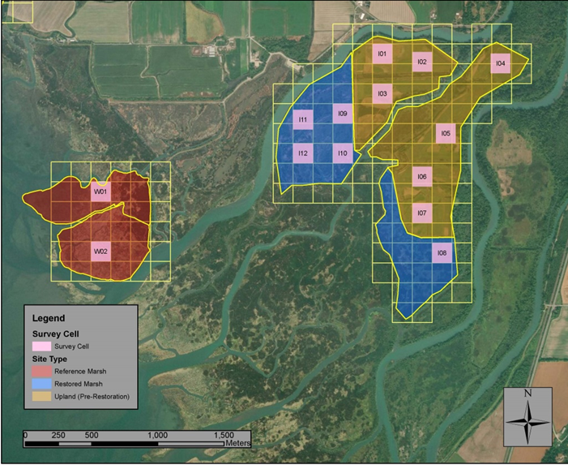

Figure 1. Example of sampling cell selection using 150-meter grid cells. Transect surveys for waterfowl and shorebirds are conducted by walking a straight line through the middle of the cell. Point count surveys for landbirds and secretive wetland birds are conducted from a stationary point in the center of the cell.

Table 1. Target species groups and survey seasons
Taxa | Winter (post-hunting) | Spring (migration) | Breeding | Fall (migration)
Waterfowl | 1 February – 15 March | 15 March – 15 April | N/A | N/A
Shorebirds | 1 February – 15 March | 15 April – 15 May | N/A | 1 August – 30 Sept.
Landbirds | N/A | N/A | 1 May – 30 June | N/A
Secretive Wetland Birds | N/A | N/A | 1 May – 30 June | N/A

data input and storage

We are currently exploring data input and storage solutions that will support aggregation of data from across project sites, facilitate data analysis, and allow user-defined levels of data sharing.

Waterfowl Module
Target Species: Mallard, Green-winged Teal, Northern Pintail. These species were selected because they are prevalent in low marsh zone and are of management and conservation interest.

Seasons:
Winter (post-hunting): 1 February – 15 March
Pre-breeding (migratory): 15 March – 15 April

Methodology:
Design: 150 m grid cells w/transect surveys across center. Random selection of first cell and then systematic spacing
Habitat focus: Low marsh
Timing: 6 surveys (3 high tide >6ft, 3 low < 6ft), spread evenly across each survey season and tidal spectrum (e.g., 6, 9 and 12 ft during high tide)
Avian Survey: species id, detection type, and # of individuals
Covariates: see Table 2

Avian response to restoration modifications – Waterfowl
- Habitat focus includes pre-restoration habitats
- Reference sites desirable

Shorebird Module
Target Species: Dunlin, Black-bellied Plover, Greater Yellowlegs, Western Sandpiper, Least Sandpiper. These species were selected because they are prevalent in low marsh zone, include species present in each survey period, and have significant data gaps regarding habitat use.

Seasons:
Winter (post-hunting): 1 February – 15 March
Spring migration*: 15 April – 15 May
Fall: 1 August – 30 September

* Least and Western Sandpipers

Methodology:
Design: 150 m grid cells w/transect surveys. Random selection of first cell and then systematic spacing (same as waterfowl)
Habitat focus: Low marsh (see definition above)
Timing: 6 surveys at tide heights when habitat is available for shorebird to use. We define available habitat as a tide height where water depth in any part of the cell survey cell is < 4 inches (not including channels and ponds). Surveys should be spread evenly across the tidal spectrum (for the individual site) and across the period.
Avian Survey: species id, detection type, and # of individuals
Covariates: see Table 2

Avian response to restoration modifications - Shorebirds
• Habitat focus includes pre-restoration habitat
• Reference sites desirable
• 6 surveys (3 high tide >6ft, 3 low), spread across the period

Secretive Wetland Birds Module

Species of interest: Wilson’s Snipe, American Bittern, Sora, Virginia Rail. These species were selected because they are prevalent in low marsh zone and are of conservation and management interest.

Season:
Breeding: 1 May – 30 June

Methodology:
Design: 150m grid cells with survey point at center. Standardized North American Marsh Bird Monitoring Protocol using broadcast surveys (Conway 2011).
Habitat focus: estuarine and brackish marsh
Timing: 3 morning surveys, spread across the sampling period.
Avian Survey: Follow Conway protocol (species id, detection type, every survey interval the individual is detected.)
Covariates: see Table 2

Avian response to restoration modifications – Secretive wetland birds
• Habitat focus includes pre-restoration habitat
• Reference sites desirable

Landbirds Module

Species of interest: Marsh Wren, Red-winged blackbird, Common Yellowthroat, Savannah Sparrow, Song Sparrow, Swallow sp.. These species were selected because they can be found in the low marsh zone and are of conservation and management interest.

Season:
Breeding: May 1 – June 30

Methodology:
Design: 150 m grid cells with survey point at center. Random selection of cell and then systematic placement throughout low marsh.
Habitat focus: low marsh, adjacent dikes and levees
Timing: 3 morning surveys. Counts should occur between the period 30 minutes before sunrise and approximately 4 to 5 hours after sunrise or when bird activity is noticeably diminished, whichever occurs first. Surveys should occur when most of the plot has dewatered and should not be conducted if water depth is > 6 inches across the cell.
Avian Survey: Estimate distance out to 125 m, but also note whether bird in or out of the cell (The distance to cell edge is 75 m while to corners is 116 m.
- The duration of each point count survey is 5 minutes
- Record how first detected, aural (song, call), visual, or flyover
Covariates: see Table 2

Avian response to restoration modifications - Landbirds
• Habitat focus includes pre-restoration habitat
• Reference sites desirable

Table 2. Certain field covariates are collected concurrently with each survey, while others are collected just once per survey period. Covariate sampling that occurs just once should be conducted at low tide when sites are dewatered. Sites may have large amounts of downed vegetation, percent cover variables do not include downed thatch that is angled > 45 degrees toward ground. Perches include trees, shrubs, down woody debris, logs, etc.
Timing | Covariate
Concurrent with survey | Vegetation height (mean of sampling period)
 | % bare ground
 | % veg cover
 | % water cover
 | Tide height @ survey
 | Weather
Once per survey period | Salinity (digital)
 | Elevation (digital)
 | Channels/ag ditches (length, area, age) (digital)
 | Dominant species of the survey cell, with percent cover
 | Percent cover standing live non-woody vegetation > 1m
 | Percent cover standing live non-woody vegetation < 1m
 | Number of visible perch or roost-like structures > 1m tall
 | Number of visible perch or roost-like structures < 1m tall
 | Max height of non-woody vegetation in survey cell

contacts For more information

Primary Contact: Trina Bayard, Audubon Washington: trina.bayard@audubon.org
Gary Slater, Ecostudies Institute: glslater@ecoinst.org
Amanda Summers, Stillaguamish Tribe: asummers@stillaguamish.com
Kyle Spragens, Washington Department of Fish and Wildlife: Kyle.Spragens@dfw.wa.gov

Conway, C. 2011. Standardized North American Marsh Bird Monitoring Protocol. Waterbirds, 34. https://doi.org/10.1675/063.034.0307
If participating in Puget Sound Bird Observatory Secretive Wetland Bird Study, conduct a second 4-minute call-broadcast period to follow PSBO protocol

