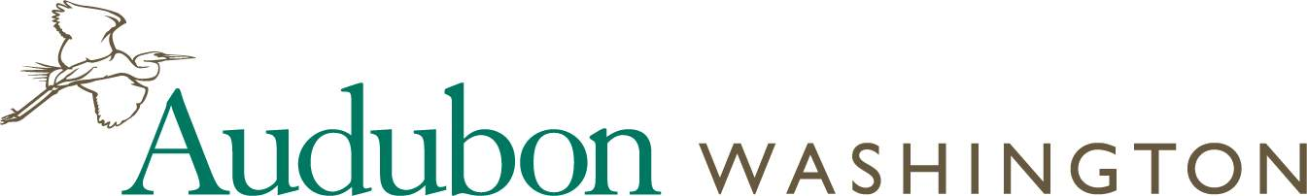

HELEN ENGLE AWARDEES
(Award initiated in Fall 2013)

2013 – Gretchen Starke, Vancouver Audubon Society
2014 – Ken Wiersema, Olympic Peninsula Audubon Society
2015 – Susan Markey, Black Hills Audubon Society
2016 – Dana Ward, Lower Columbia Basin Audubon Society
2017 – Darrel Whipple, Willapa Hills Audubon Society
2018 – Gene and Sandy Bullock, Kitsap Audubon Society
2019 – Cindy Flanagan, Rainier Audubon Society
2020 – Lindell Haggin, Spokane Audubon Society
2021 – Tim Manns, Skagit Audubon Society
2022 – Don and Judy Willott, Kitsap Audubon Society

